Completed Actions

Just tick the box that best describes where you are at with that particular activity.

A = Totally Nailed It
B = Need some improvement
C = Needs big changes
D = Yes to be completed
E = Not applicable

 |  | A | B | C | D | E
HOW TO SET EVERYTHING UP
- My Market | Industry/ Customer Type, for example Relationships, Weight Loss, Emotional & Mental Health, Students, Spiritual Seekers  I know my Industry or Customer Type
- Tribe | The common description for tribe. For example, want to lose weight, want better relationships, want to attract their life partner, empaths.  I know who my tribe is and am specific about it.
- Avatar | - Description  - Gender  - Age  - Pain  - Problem  - Personality  - Prayer  - Answer
- My Database | - Name  - Preferred Name  - Phone  - WhatsApp  - Email  - Social Media Link  - Profession  - Reference  - How did you meet  - Current situation  - Desired situation  - What free things have they signed up for  - What have they purchased  - What can they potentially purchase  - What have they expressed future interest in  - Discovery calls  - Consultation calls  - Notes  - Do not Contact  - Actions
- My SWOT | - Strengths  - Weaknesses  - Opportunities  - Threats  - Audit of my tribes’ feedback on my strengths and weaknesses
- My Values | The 5 values that are important to you in your business or private practice.  I know my values and I live by them and share them with any ambassadors or team members.
- Souls Message | I help [TRIBE] to [GET RESULT] by [YOUR OFFER]
- Market Research | - Facebook 5 Posts  - LinkedIn 5 Posts  - Instagram 9 Posts  - Internet Search Other Players  - Open Questions on FB Timeline  - Connecting on FB Groups: interacting, asking questions and reading  - Open Questions on LinkedIn Timeline  - Questions on Instagram Stories  - Conversations with friendlies
- Sooper Dooper Focus  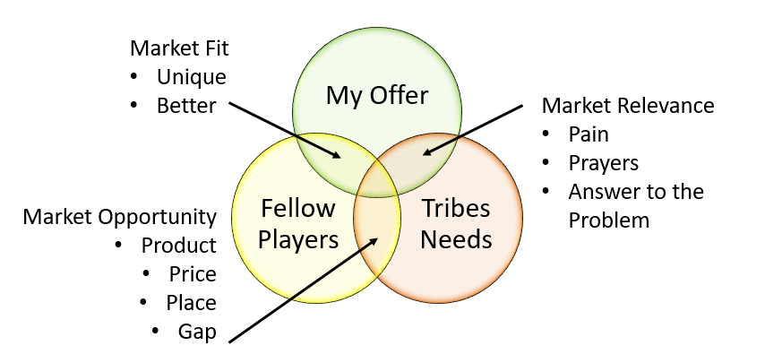 | - My tribe wants it and it’s important for them to get it  - Other players offer something similar and mine is better  - It answers my tribe’s prayers and its worth investing to get it  - I am confident in my offer and know it makes a difference
- Soul Power Activities | - FB Groups Profiled & 3 Selected where your tribe is  - LinkedIn Search Terms clear to find your tribe  - Instagram 4 Hashtags selected where your tribe is  - Calendly or booking link for Discovery Call
- Discovery Script | - Short Chat  - Long with presentation  - Update Database
- Consultation Script | - Practiced  - Updated  - Calls Recorded  - CC Tracking  - Update Database
ATTRACTING MY TRIBE
- Souls Offer | - Product  - Positioning  - Price  - Place  - Promotion  - Pitch  - Proof  - Presentation (Souls Presentation)  - Place (Social)
- Soul Brand | Soul Brand Essence is your summary description of your tribe, their pain, problems and prayers with the emotional benefits and deeper benefits aligned to your offer and what makes it unique and special.  I know my soul brand and it’s about my tribe and my unique offer.
- Echoing Emotions | The 5 emotions your tribe wants to feel when they have an interaction with you that makes them want to explore more and move from awareness to interest to desire and action.  I know My Echoing Emotions & they work well.
- Mood Board | - Colour pallet  - Fonts  - Visuals  - Textures  My Mood Board fits with my soul brand and I have tested it with my Soul family and they have confirmed the emotions.
- Value Diamonds | These are the 6-8 areas of communication on social media, WhatsApp or e-mail where you provide value to your tribe and build loyal and raving fans.  I know my value diamonds and all my communications come out of my value diamonds.
- Facebook | - Profile Picture  - Banner  - Profile  - 5 Posts aligned to Soul Brand  - FB LIVE  - Videos
- LinkedIn | - Profile Picture  - Headline  - Profile Section  - 5 Posts aligned to your Soul Brand  - Videos  - LinkedIn Profile Mastery
- Instagram | - Profile Picture  - Bio  - 9 Posts aligned to your message  - Hashtags  - Insta LIVE  - Videos (IGTV)  - Stories Plan
- Direct Outreach | - Have an introduction e-mail ready  - Know what you will do on the follow up phone call
- E-mail Campaign | - Souls Value e-mails  - Freebie Sign Up Form (Mailchimp)  - Nurture Campaign
- Souls Value | - Discovery Presentation  - Souls Presentation  - Mini Seminar  - Introductory Talk  - Group Live Call Process  - External Party Process
- Joint Venture Partnership | - Identify potential partners  - Make contact  - Offer something that’s of value to them  - Explore being able to complete a Souls Value Event for their database  - Send out invitations  - Follow up process
NUTURING MY TRIBE
- Souls Relationship | - Weekly Tip  - Video/ IGTV  - Live FB/ Insta
- Website Mastery | - “Free” Resources  - Discovery Call to action  - Alignment with brand colours  - Copy in the frame of tribe and not you
- My Final Plan | - Update the final plan
- Souls Team | - Freelance  - In house

My Personal Development Plan

Continue Doing | Do More Of
Start Doing | Stop Doing

How many clients do I want over the next 30 days and at what price?

_______

My Top 3 Actions over the next 30 days

1.
2.
3.

My Top 2 Energy & Mindset actions over the next 30 days

1.
2.

What is the No. 1 area I need help and where can I get that help?

1.

